**DT228 DT282 Year 2 Databases I Continuous Assessment**

**Case Study for CA Part I 2017/2018**

A computer games shop called ‘Games Galore’ sells electronic games some of the games can run on several gaming consoles. The shop also sells gaming consoles and accessories, both generic accessories and those for specific consoles. Games Galore want to design an information system to support all the retail activities of the shop.

The details of each item of ***stock*** available for sale in the shop will be stored. These include a ***unique numerical stock code*** (5 digits), the ***type of item*** it is (***game***, ***console***, ***accessory*** etc.), a description, the number of items of that product currently in stock, the price the shop paid for a single item, and the ***percentage mark-up*** they intend to add when selling (e.g. 10% this will allow the retail price to be calculated so if the shop paid 100€ for an item if the markup is 10% they will sell it for 110). In addition, for each game its name, release date, console needed, the age group it is suitable for, and the ***skills*** needed to play the game are stored.

The shop buys games, consoles and accessories from several ***suppliers*** and needs to store details about these suppliers including their company name, main email (must include an @ symbol) and phone contact details. Each supplier is given a unique numerical ID (5 digits). Suppliers can supply many different kinds of game, console and accessory.

Each supplier can have one or more sales representatives and for each supplier the name, email and phone contact of their representatives needs to be stored. Each ***representative*** has a unique numerical ID (5 digits). A representative can work for one or more suppliers.

Each item sold in the shop can be supplied by many suppliers and a supplier can supply several different items. To place an order with a supplier ***(supplier order)***, the shop identifies the items to be ordered and adds the quantity of each that they want to order. Each order has a unique order number (6 characters which must start with a letter followed by 5 digits).

The date the order is made is also stored in addition to the sales representative with whom the order was made. When the order is delivered, the ***delivery*** date is recorded.

The games shop has a panel of ***reviewers*** who review the games that the shop stocks. Each reviewer has a unique username (8 characters in length but can include numerical values); a password (must be at least 8 characters in length but can include numerical values); and an e-mail address (which must include the @ symbol and should be unique i.e. two reviewers cannot have the same email address).

When he/she wants to add a review, the reviewer will log on to the ***system*** which will present them with a list of games available for review, he/she will then select the game to be reviewed and enter in the review text. The date the review is entered is stored with the review. Many reviewers can review a game and a reviewer can review many games. Each reviewer can only review a game once. The following is a list of reviews that have been posted against one of the games:

**DT228 DT282 Year 2 Databases I Continuous Assessment**

**Case Study for CA Part I 2017/2018**

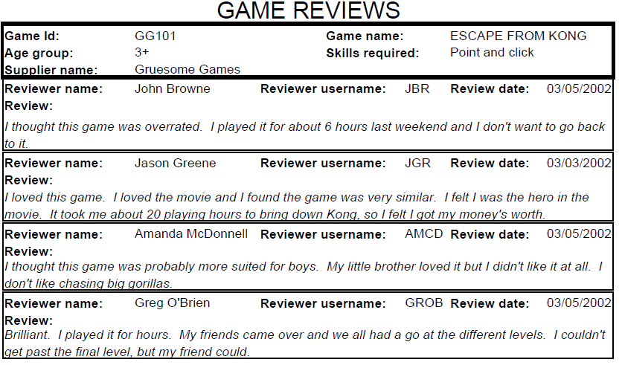

1. ***Stock***
2. ***Type-Of-Item***
3. ***Game***
4. ***skills***
5. ***Console***
6. ***Accessory***
7. ***percentageMarkup***
8. ***Suppliers***
9. ***Sale Representive***
10. ***Supplier_order***
11. ***Delivery***
12. ***Reviewers***
13. ***System***